Sustainable Energy Security for India – Challenges and Options

Anil Kakodkar

Allow me to express my greetings to all of you on the occasion of the Platinum Jubilee of the Khalsa College. It is indeed an important occasion in the life of an educational institution and I am happy to be a part of it. I am sure you must be having year round activities to commemorate the occasion. My best wishes for your future successes. I am also grateful to Indian Physics Association for the invitation to deliver this DAE – C.V.Raman lecture.

In this lecture today, I intend presenting to you a sort of broad philosophical overview of the energy issue; I am going to do that in the context of what one may call as our sustainable future and not just in the context of the crisis as we see it today. This is because while we see some crisis on energy scene today but if we don’t act in a proactive and timely manner, this crisis is likely to get much bigger than the one that we face today.

Let us begin with a vision of sustainable India, India where, hopefully, the population will stabilize, an India where there will be no additional energy requirement in per capita terms, and where we can be assured of sustaining such a situation virtually for all time to come. That is what I mean by our sustainable energy future. I am going to develop the theme from such a prospect, and then analyze what is it that we need to do to reach there. For the purpose of this lecture, I am going to use the term “energy” to mean electrical power.

The first question that we must address is how much of electricity do we need. There are different ways of approaching this question, but the most straight forward way would be to look at the relationship between per capita electricity use and the quality of life. And how do you measure the quality of life? There are many parameters which have been used to measure quality of life, but now we have what is known as the “Human Development Index” worked out by the United Nations, which has gone through several evolutions. One can correlate human development index with per capita electricity use (Fig. 1). We can observe two important phases, an initial phase where when you add more energy, the human development index rises sharply. There is, of course, a lot of scatter, but that scatter is only to be expected because there are other parameters which also govern the human development index. When you are in this phase, say between zero to a few thousand kilowatt- hours (kWh) per capita, you can see a steady rise in the index. However, after a point, which is beyond 6000 to 7000 kWh per person per year, the trend saturates and additional per capita electricity does not really add to the betterment of human development index.

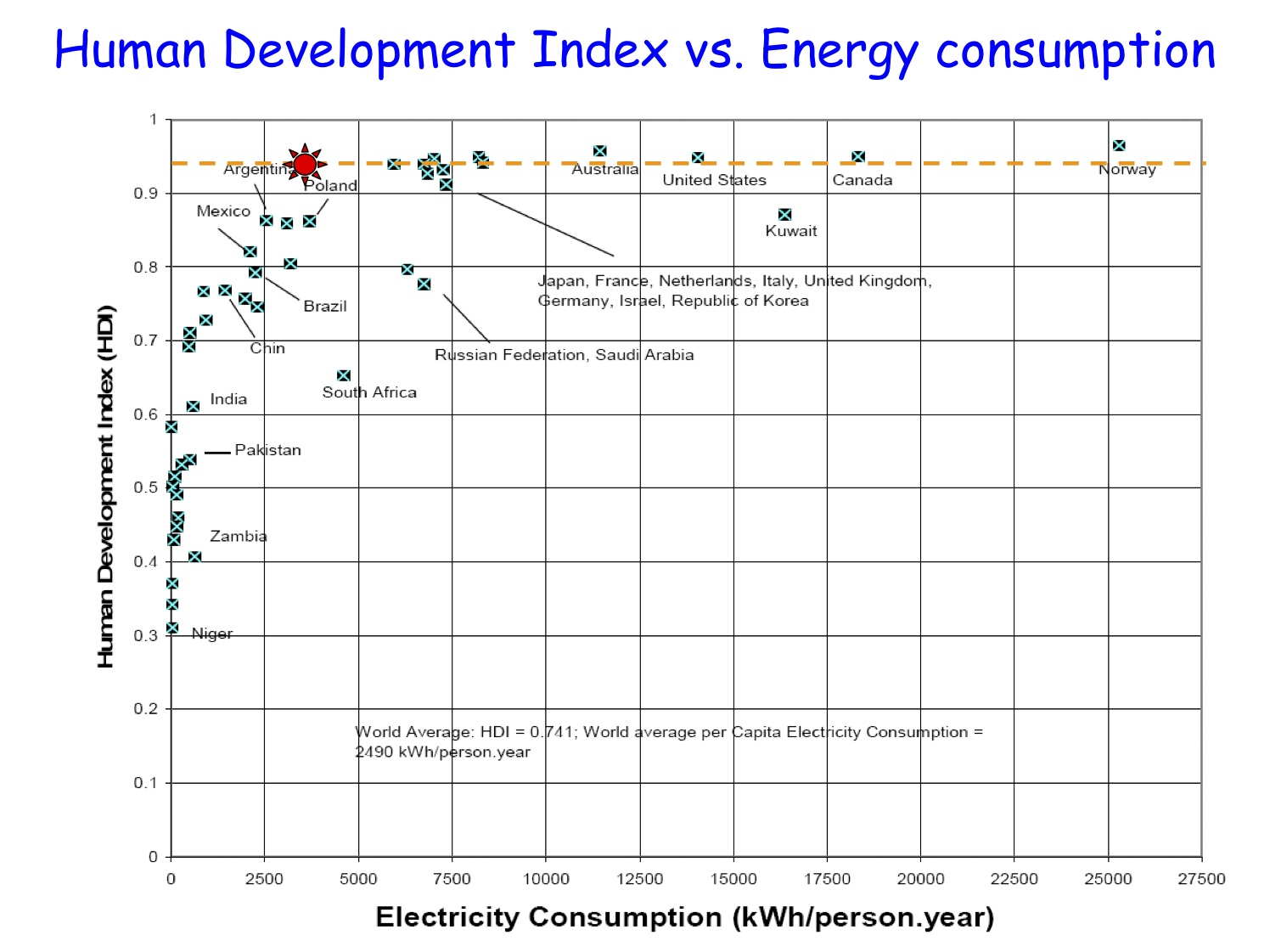
Figure 1 : Human Development Index and Electricity Consumption (Source: Department of Energy, USA)

So, in terms of electricity use there seems to be an optimum and that optimum lies somewhere around 5000 kWh per capita. Up to that point there is a significant gain beyond this there is not much gain. So we can conclude that per capita electricity use of something of the order of 5000 kWh should be the target that we should aim at in the steady state.

Some people argue that if we conserve energy we will be able to solve the problem of energy shortage. They ask why we should increase the consumption at all. We should live within our means. Clearly this is an important philosophy that we should always keep at the back of our mind. But, it is also important to realize that we live in an interdependent world. Someone might assert that he does not need say a television in the house. There are people who will sympathize with this point of view but it is only a matter of time before they get into lot of societal compulsions, compulsions from neighbors, children etc. Same applies to using a mobile, a refrigerator, an air conditioner and other energy dependent devices. If we want a society at peace with itself, it is important that it is also at peace with the rest of the world. So stretching a simple logic beyond a point does not work though these arguments do have some strength in terms of conservation, and we should respect them. Conservation, which is important, is however not the answer to reaching the goal of 5000 kWh per capita when our current use is only around 650-700 kWh. To ensure a quality of life comparable to the best in the world we should aim at this magic figure of about 5000 kWh. This is reasonable since it is quite modest at half of the average of the industralised world.

The next question is what it implies in terms of mobilizing necessary energy resources and its global context. There is now a growing concern on the effect that the addition of carbon dioxide to the environment is going to have on the climate. This is where a mind boggling situation arises. The world as a whole today utilizes electrical energy of the order of 18 to 20 Trillion kWh. If India were to increase its consumption to 5000 kWh per capita with a stabilized population of say 1.6 billion, India by itself would need around 8 Trillion kWh of electricity. This would constitute nearly 40% of the total electricity produced in the world (Fig. 2). So we are not just talking about a small change in the global energy scene, we are talking about a huge challenge. All these talks that we hear about protecting the earth and pressure on India in that context have this hard reality in the background. World is very much concerned that if India starts using so much energy what will happen to their energy supply. And if India starts consuming energy at such a level in business as usual manner, what will happen to climate change issue. This is at the heart of the climate change debate.

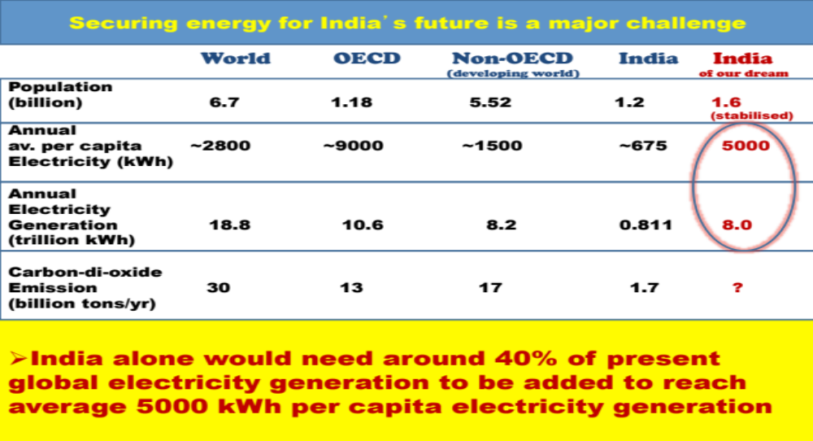
Figure 2 : Electricity consumption in India and the world. India alone need 40% of the global total electricity generation to reach an average of 5000 kWh per person.

It is important to realize that in order to achieve the aforesaid level of energy production we would need new energy sources. At the same time we have to remain conscious about the carbon dioxide emission which is primarily responsible for the global climate change. Today the world emits something like 30 billion tons of carbon dioxide per year, of which the Indian contribution is only about 1.7 billion tons, which is a very small faction. But if we were to produce 5000 kWh per capita i.e., 8 Trillion kWh, which is roughly 10 times larger than the present electricity production in the country, the present emission of 1.7 billion tons per annum would become 17 billion tons per annum in the business as usual mode. We cannot be seen adding more than 50% of the present global CO₂ emission when the world is clamoring about reducing CO₂ emission and even a small addition of CO₂ is a cause of concern. Clearly “business as usual” mode for our electricity production is not the way forward. I want to impress this point as we are talking about a major transformation in our energy situation.

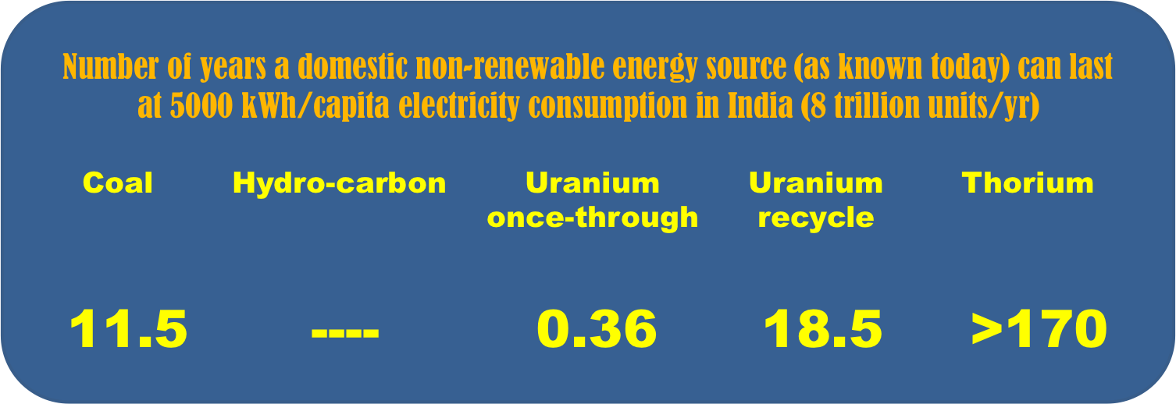

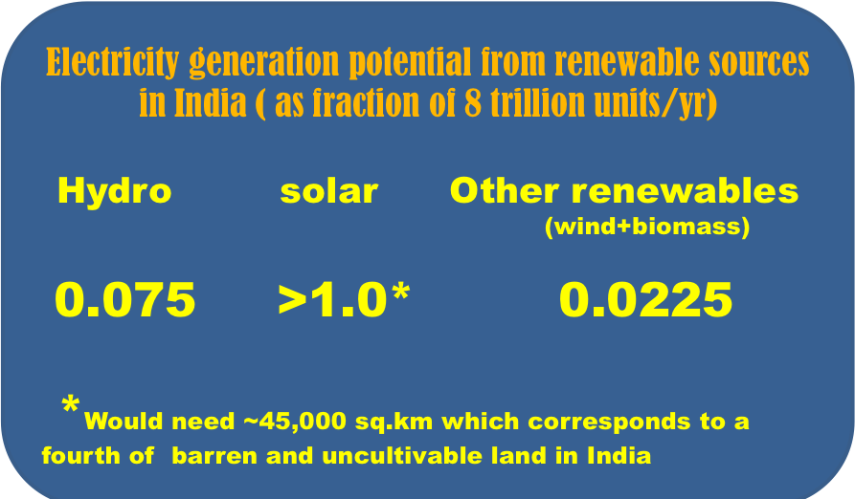
Figure 3:(a) Non-renewable energy reserves in India (b) Renewable energy reserves. Only Thorium and solar energy can be considered to be sustainable in the long run.
Let’s now look at from where we can get this additional energy -- about 8 trillion units of electricity per year. We should look at each energy resources that we have. Energy resources are of two kinds, those which are exhaustible and those which are renewable.

Focusing our attention on the non-renewable energy resources, we can look at each of these resources in terms of number of years that a particular domestic non-renewable source would last if we consumed energy at a rate of 5000 kWh per capita, i.e. at 8 trillion units per year. It is estimated that our total reserve of the current coal reserves that we know will last for just 11 years. Uranium which provides fuel for running nuclear reactors will last for just few months in once through mode. In fast breeder reactors, we recycle the used Uranium. Even then it will last for only 18 years. So of all the sources available on the Indian land mass that we can think of, Thorium alone has the capability of meeting our requirement as it can last for a couple of centuries. And that’s the importance of Thorium in the Indian context.

Lets’ now look at renewable sources. Renewable sources cannot be measured the same way as we did for the non-renewable counterpart. The way to look at it is to determine what fraction of our projected 8 trillion units of electricity can be practicably produced by a particular renewable source. Hydro potential in India is very large. But at that level of use its contribution can be just 7.5 percent. Other renewable sources like wind, biomass, and all others would come to around 2 to 2.5 percent. Solar energy on the other hand is abundant and can meet our entire electricity requirements provided we can year mark something like 45,000 square km area which corresponds to a fourth of total barren and uncultivable land area in the country.

Electricity supply is crucial to economic development and it is very important that we make use of all available energy resources. I am also a champion for using coal because I believe “a bird in hand is always better than two in the bush”. Coal is our mainstay. So we must make use of all the resources that we have, and doing so is important in the context of today’s crisis. But when we talk about preparing for the future, it is important that we prepare ourselves to make full use of Thorium and make full use of the solar energy. And do realize that both are free from CO₂ emission. And if we do that we can address both the challenges which I talked about. I have not considered fusion energy at this moment because it is still in the developmental stage. In the time frame of 40 or 50 years that we need to focus on right now, energy from nuclear fusion is unlikely to become a reality. I am certain it will happen one day but it may be beyond the time frame. When that happens we can make that transition. While we must accelerate such development, we cannot bank upon it at this moment in terms of energy planning for preparing our future.

Many times it is asked, if that be so, then why not we start making large scale use of Thorium right away or for that matter why not only solar, why do we need both? To my mind such questions are inappropriate. First of all, any country cannot afford to depend on any single energy source. We cannot have all eggs in the same basket and make the country hostage to an unforeseen situation. One must have diversity and hence we must harness both. More importantly, there is lot of complimentarity between Thorium and solar. Solar energy is diffused and well suited for distributed electricity generation; nuclear energy on the other hand is concentrated and well suited for bulk central electricity generation. We do not get solar energy round the clock so we need to store it. That adds to the capital cost making viable solar energy that much more distant. Nuclear energy is commercially viable even today. We can develop nuclear generation capacity in a commercially viable manner without any form of subsidy. Thus, we must pursue both the alternative together.

One of the main technology goals in the context of developing solar energy is to cut down the capital cost. Today deployment of solar energy is dependent on Government subsidies. Were it not for subsidies, the challenge of bringing the tariff within the competitive range would have become that much bigger.

I think there is now enough scientific evidence, that global warming is for real (Fig. 4). The only thing we do not know is how close we are to the tipping point. But if we reach that point then there would be no time for correction. This is a big disaster waiting to happen and we need to act now so as to secure the survival of our future generations.

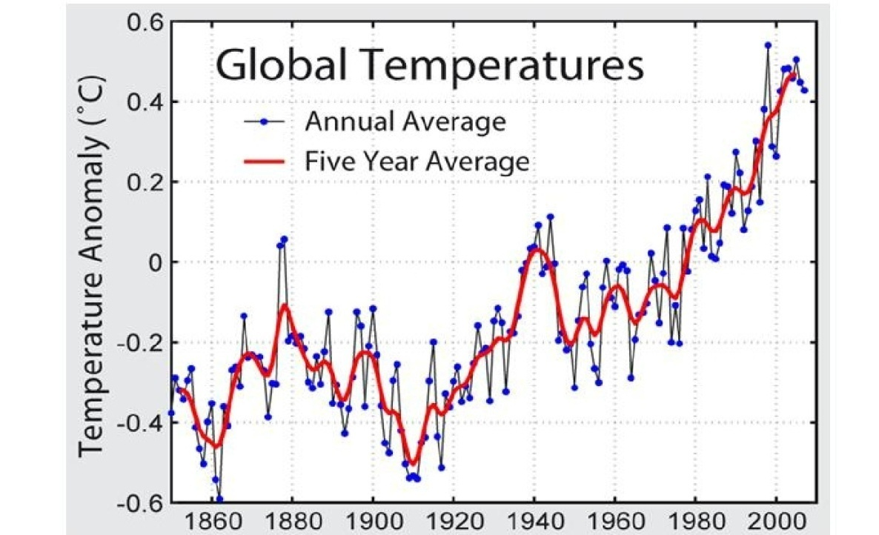
Figure 4: Global average temperature over last one and a half century showing a more or less steady increase over the last 50 years. The fluctuations and their cycles can be correlated with various events such as solar cycles.

Coming now to the other question i.e. when we have so much of Thorium, why don’t we have Thorium reactors today? We have been talking of Thorium right since the time the Atomic Energy program started in the country but we don’t see much of energy being derived from Thorium even today. The answer to that question lies in the fact that Thorium by itself cannot fission and release nuclear energy. We can however convert Thorium into a fissile material which then becomes a vast energy source. The only
fissionable nuclear fuel available in the nature is Uranium-235, which is a very small content is natural Uranium. Thus any nuclear energy programme can begin only with Uranium and not with Thorium. That’s point number one. So that’s what is happening presently in India. One can set up Uranium reactors only to the extent one has Uranium. We have seen earlier that we do not have sufficient Uranium deposits. We require Uranium reactors to make a start but it is not going to be the answer to our long term problem.

An important thing about a nuclear reactor is that as it consumes fissile material, it also produces fissile material (Fig. 5). While the thermal reactors that we are presently constructing also produce fissile material but that is not as much as it consumes. A fast breeder reactor on the other hand produces much more fissile material as compared to what it consumes. So, if we can quickly setup fast reactors, then not only can we step up our energy generation capacity, but we can also breed more fuel and further add to that capacity. That is the logic behind the second stage of the Indian nuclear power program. We can then even convert Thorium on a large scale. The rate at which we can use Thorium is dependent on what is the fast reactor capacity that we have already setup, because those would be the cooking beds for converting Thorium to fissile material -Uranium - 233.

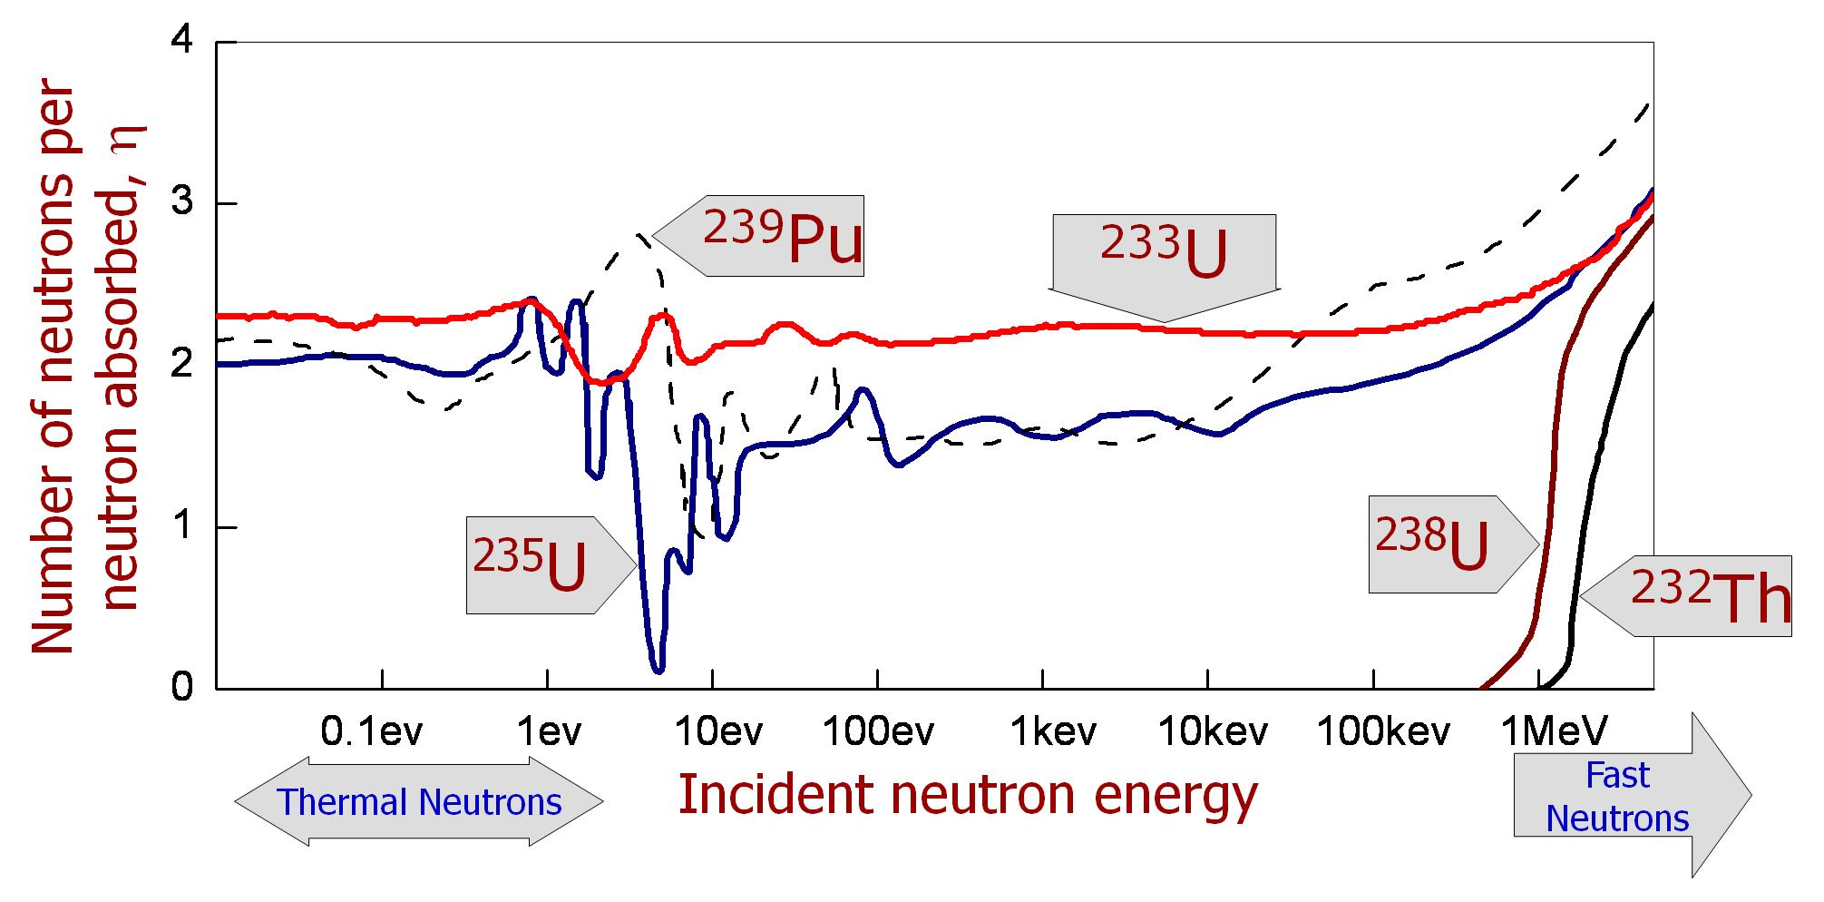

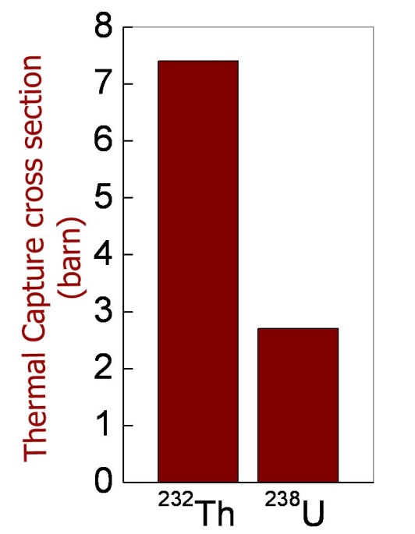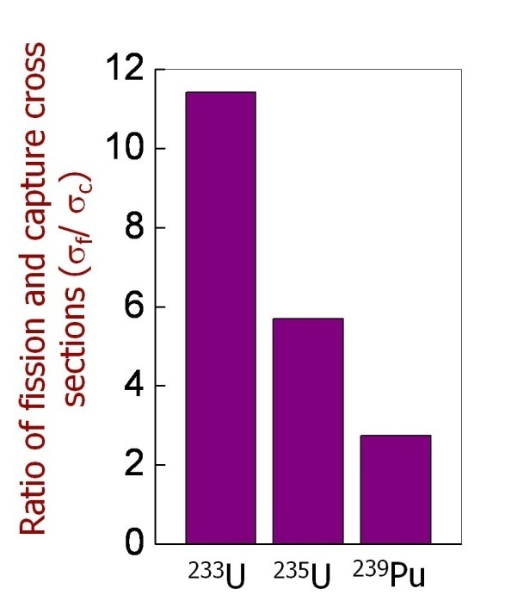
Figure 5: Neutron yield per neutron absorbed v/s. incident neutron energy. The bar graph at the bottom shows (a) capture cross sections for Th-232 and U-238 (b) fission cross sections of U-233, U-235 and Pu-239.

In the 3 stage program, the first stage is of Uranium reactors, the second stage is of fast reactors and the third stage is of Thorium based reactors and these have to happen in that sequence. As you know we are in commercial operation for the first stage and are about to commence commercial operation of the 2nd stage. Once the 2nd stage goes to a significant level, it would be time for large scale deployment of the 3rd stage and that’s the reason you don’t see the Thorium reactors today. A bird’s eye view of the three stage of Indian Atomic Energy Program is shown in Fig. 6.

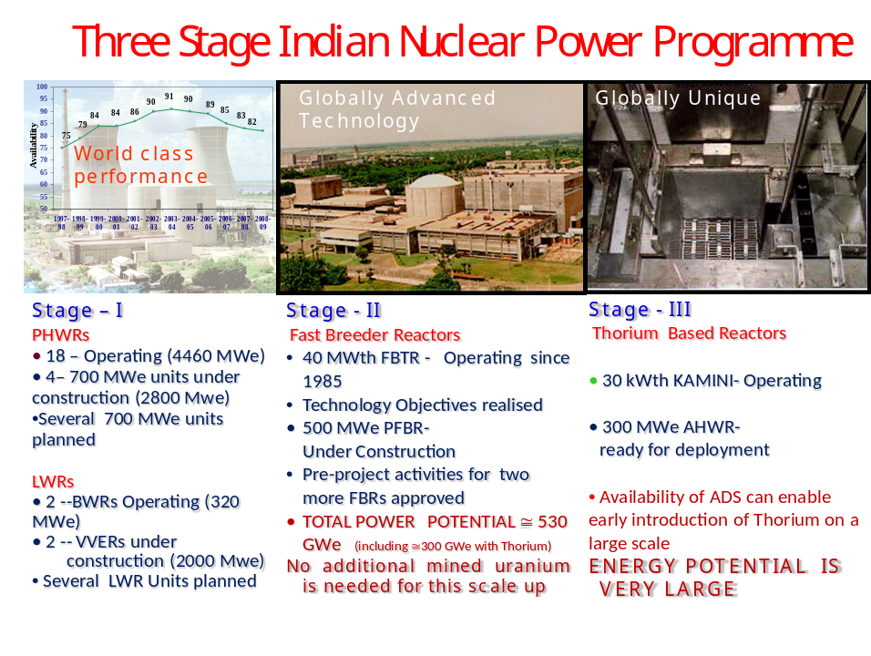
Figure 6: The three stage nuclear power program -- Present and Future.

On the technology front however, a lot is happening. We have made progress on all the 3 stages of the technology. I am sure all of you know that Indian pressurized heavy water reactors have been recognized by World Association of Nuclear Operators for their world class performance. There are not too many countries that are knowledgeable in the fast reactor technology and where Thorium is concerned, we are unique. If I were to give you a progress card of Atomic Energy program, I would say that in the 1st stage of Uranium reactors we have demonstrated world class performance based on indigenous research and development, in the 2nd stage we have demonstrated that we have globally advanced technological capability and will be soon ready with a 500 MWe prototype fast breeder reactor. I think almost 90% work is done on this project. When completed, it would be the second largest fast breeder reactor operating in the world. Our programme on utilization of Thorium for energy production has progressed in a comprehensive manner and today we already have a small research reactor KAMINI that runs on Uranium 233 derived from Thorium. We are unique in this technology because that is dictated by our large endowment of Thorium when our Uranium resource position is very modest. There are of course countries that have plenty of Thorium but they also have plenty of Uranium; there are others who have plenty of Thorium but do not have nuclear capability. In some sense thus India is unique and has the necessary technical capability to be able to take the initiative and provide a leadership in this technology. Rest of the world will, sooner or later, need this technology because world over Thorium is much more abundant than Uranium. Our taking a leadership at this time has the potential of making us a prime technology and energy provider in this niche area.

Now let us look at the sum again. I had told you the end point; that we need to produce 8 trillion units of electricity annually to reach 5000 kWh per capita. What should be the profile with which we will approach that point? To get at that, we need to look at the growth in demand for electricity and the corresponding augmentation of capacity of generation. The growth in electricity demand has something to do with the growth in the economy. There is a concept of energy elasticity which is defined as the ratio of increase in energy consumption needed to achieve a given increase in the GDP. If the energy elasticity is 1 and we want 10% growth in the economy, we have to supply 10% more electricity into the system. The energy elasticity depends on the state of development, type of economic activity and such other factors. With progress the energy elasticity is expected to decrease. One can do a comprehensive calculation which was in fact done in the Department of Atomic Energy in 2004. The relevant report is available on the website of the DAE.

The projected energy requirement of 5000 kWh per capita or 8 trillion units of total electricity production translates into a generation capacity of 1300 GWe, which is roughly 10 times the electricity that we produce today!

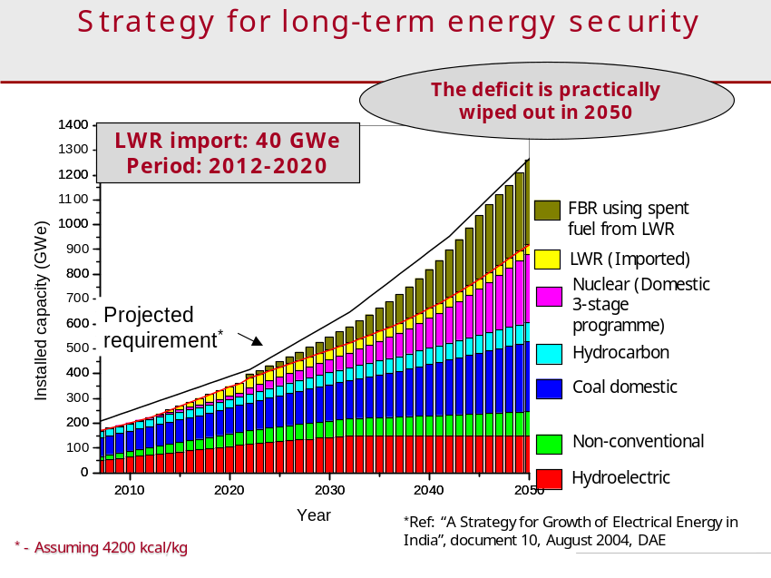

Figure 7 : Projected Energy Requirement and ways of bridging the gap.

Let us now discuss how to get to this goal. Even after considering contributions from all different modes of electricity production, such as, coal, hydro-carbon, hydroelectric, non-conventional, even domestic 3 stage nuclear program in a very liberal way, there would still be a gap between the projected requirement (Fig. 7) and what these modes can meet all together. Further, the gap is quite large and it would increase with time. It would roughly correspond to 400,000 Megawatts of electricity if the domestic programme proceeds as planned. Could we meet this shortfall by importing as we do now? For instance, if we decide to import coal, we would require 1.6 billion tons of coal annually. Our economy is very strongly dependent on our oil bill, as we import lot of oil, and if we are going to import coal at that level then you can imagine what will happen to the balance of payment situation. And even if you decide to forget that, forget the cost involved in importing, simply to provide the infrastructure to unload so much of coal in our ports and to transport the coal from the ports to the power stations will choke our infrastructure.

In this context an idea that was put forward is as follows. We have seen that while producing nuclear power we also produce new nuclear fuel. What is restricting us from going for nuclear power in a big way today is the fact that we do not have enough Uranium to kick start this venture. Why not, therefore, import Uranium? Till recently, this was not a feasible option for India as the international community had put embargo on India subsequent to the peaceful nuclear explosion conducted by India in 1974. However, the situation has changed now with the world acknowledging India’s responsible behavior and advanced capability in nuclear technology. So, supposing we could import enough Uranium to set up say 40,000 MWe additional nuclear capacity, a lot of problems can ease. In terms of quantity, this is not huge and does not suffer from the infrastructure problem associated with import of coal or oil. We can then recycle the used spent fuel that will come out in the fast breeder reactors which will further enhance the generation capacity. And if we do the implementation properly we can, in fact, bridge the gap without having to import any additional Uranium. That is the rationale for developing the so called the “civil nuclear cooperation” for which we went through so much of hard work.

It is important to recognize that this was a step for preparing for our future. We not only implement the 3 stage program based on domestic Uranium ( and we must continue to explore to find new Uranium deposits within the country), we also had to create conditions where we can import Uranium from outside to bridge the current gap and eventually become energy self-sufficient for all time to come. This is possible because once we bridge this gap and launch the Thorium stage; we can sustain this for over 200 years. We have plenty of Thorium and this is certainly a feasible alternative. This is the way the Atomic Energy Program is designed.

There is always a talk that while all this is fine on paper, what about the reality. Event like Fukushima has everyone scared. There was also Chernobyl. Are we not playing with the devil? So we will address this concern and ask how safe is nuclear energy?

Let us look at these concerns one by one. Firstly how safe is nuclear energy in terms of number of deaths per kWh? Let us examine this not just for the nuclear power sources but for other form of power sources as well. Figure 8 gives us the statistics over a long period. The data has been taken from internet and so anyone can refer to the web to verify the claim. There may be differences in number but the conclusions will be the same, i.e., among all energy options the fatality per Terra Watt hour of electricity produced is the least for the nuclear power. The statistics includes Chernobyl. People don’t realize that there have been major accidents in other energy systems. Agreed, people will say, but what about Cancer that can be caused by harmful radiation?

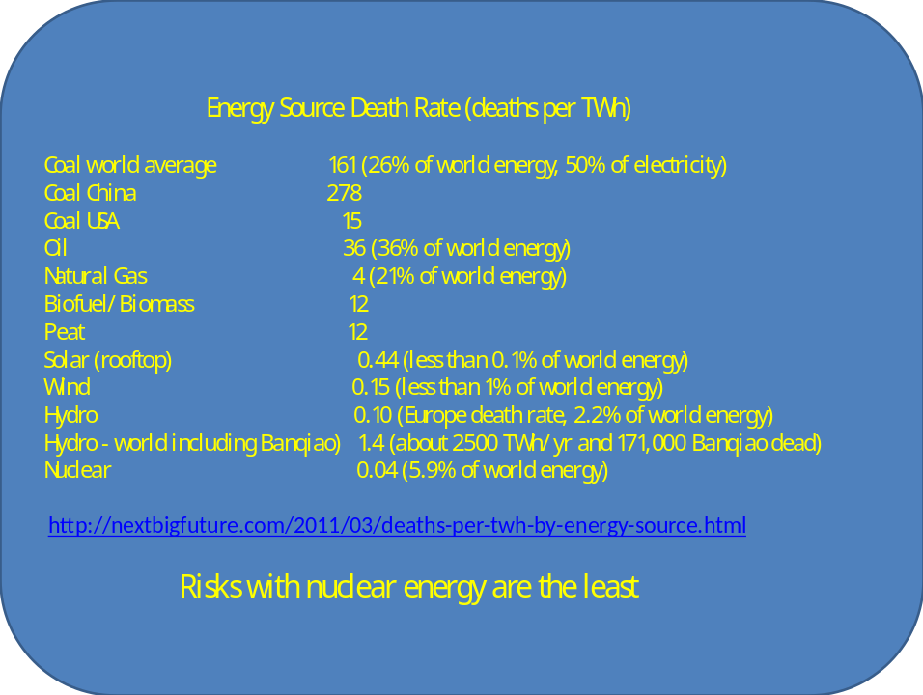

Figure 8: Death rate from various sources of energy.

In radiation protection, we have a principle called the “linear no threshold”, it’s a good principle which we adopt as a measure of ensuring conservativeness in setting up our radiation protection framework. If the radiation level is double, the consequence will be double, if it is half, then consequence will also be half. But the linear no threshold principle implies that there is no such thing like zero consequence. So if there is an accident and we start calculating the area affected by radioactivity release and number of people who live in that area, and then integrate all of it to find out the “consequence”. Since even a slight increase in radiation exposure, we assume has a consequence and integrate it over large population that happens to be there in this geographical area, we end up with a huge number as the estimated consequence. And this is what anti- nuclear people profess. Such calculations are claimed to have been done in the aftermath of Chernobyl disaster. There was a calculation done in 2006 which projected that 93,000 people would die due to cancer up to the year 2056. Yet another calculation done in 2009 claimed that 9.85 lakh people have already died by 2004. And this is what creates a big scare about nuclear energy.

What then is the reality? Radiation is present everywhere, and there are areas where there are much higher levels of radiation occurring naturally, for example in Kerala Beach sands. People out there are exposed to far more radiation then we are here in Mumbai. It has been studied scientifically and the conclusion is that there is no relationship between radiation exposure and Cancer at such levels of radiation. Consider, for example, people living in high altitude places such as Mahabaleshwar or Matheran or people who often travel by air. This group of people is exposed to a higher level of radiation than people living near sea level. There is no data to show that people who live at hill stations have higher incidence of cancer. If fact, hill stations are considered to be more healthy places to live in. The pitfall in the estimates of cancer lies in the use of the principle of linear no-threshold, which does not apply at low levels of radiation exposure. I am not saying that we should do away with this principle. It is a good basis for a sound and conservative radiation protection management under normal conditions. But such good principles cannot be used for creating public trauma.

Let us examine claims on Chernobyl consequences. What is the ground reality? Large International groups have studied this. The total number of deaths in Chernobyl was 62 of whom 47 were connected with the accident management. Remaining 15 out of 62 died of thyroid cancer caused by exposure to high level radiation. As many as 6000 suffered from thyroid cancer, which is actually curable. 134 people suffered from acute radiation syndrome of which 28 people have died (included in 47). Fig. 9 shows the distribution of mortality rate at different dose levels in case of Chernobyl. Existence of a threshold and lack of justification for estimated large consequences of the accident following the use of linear-no-threshold principle are very apparent. Driven by the conservative linear no threshold principle, which is not substantiated by surveys in high natural radiation background areas, we tend to create avoidable trauma in public mind while managing accidents. A reasonable balance needs to be exercised in deciding the intervention levels particularly for relocation of large populations. As a matter of fact American Health Physics Association has clearly stated that there is no risk to human life up to 100,000 microSv life time dose over natural radiation.

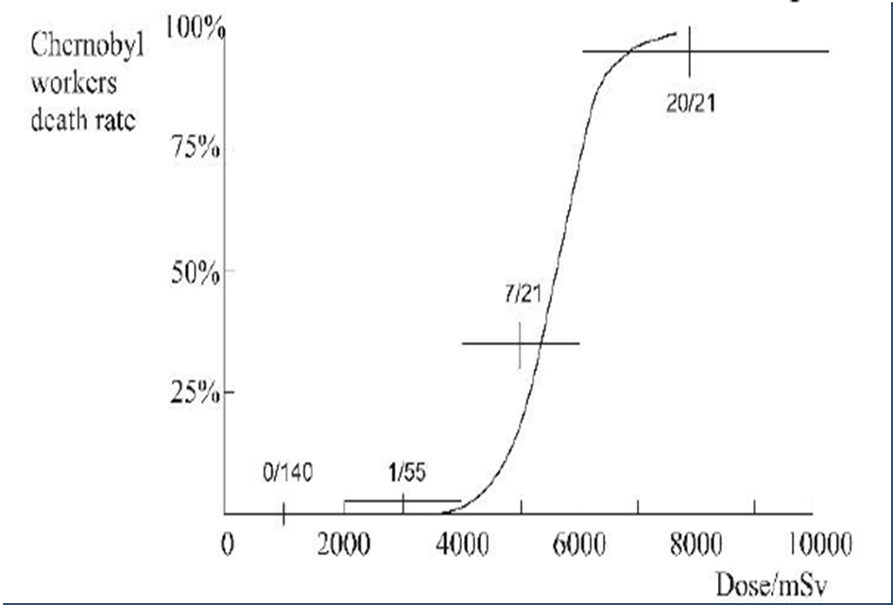
Figure 9 : Real radiation danger levels. The solid curve is for rats. The crosses show the mortality of fire fighters. The numbers near the crosses show the number who died and the number exposed to that level of radiation.

Now let’s talk about Fukushima, which is more recent. Fukushima has had no fatality due to exposure to radiation. In fact, no worker has been exposed to a dose of radiation which could have a significant probability for a serious health consequence. The devastation that occurred in Fukushima was caused by the tsunami which actually killed more 13,000 people with another 14,000 missing. But we remember Fukushima for the nuclear catastrophe that it was not.

In Fig. 10 we show the radiation dose that one is exposed to in daily life. The regulatory limit for exposure to manmade radiation is 1000 micro sieverts (Sv) per year. There are many situations where the doses far exceed this regulatory limit. Even the average natural background radiation is close to 2500 microSv. If you take a round trip Tokyo -New York– Tokyo flight, you would get 200 microSv of radiation. A variation of 400 to 500 microSv from place to place is very common.

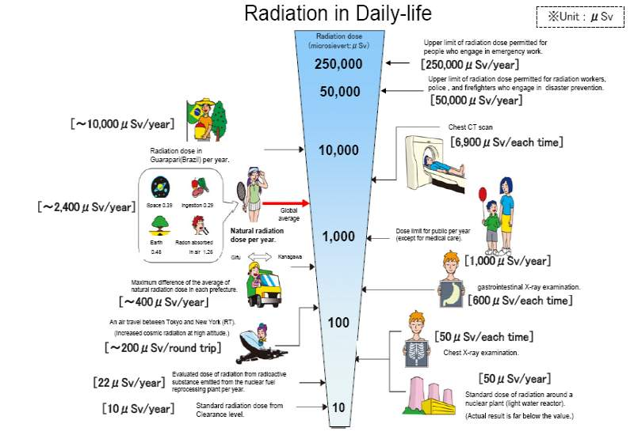
Figure 10: Radiation in daily life. One can see that on several occasions the regulatory limit is well exceeded.

Compare the above to what we have around a Nuclear Reactor. As compared to a regulatory limit of 1000 microSv per year the actual numbers are between 1-26 microSv per year (Fig. 11). So where is the question of Cancer being caused to public due to operation of a nuclear reactor? Where is the question of biodiversity being affected by nuclear reactors? According to me the so-called nuclear nightmare is a myth.

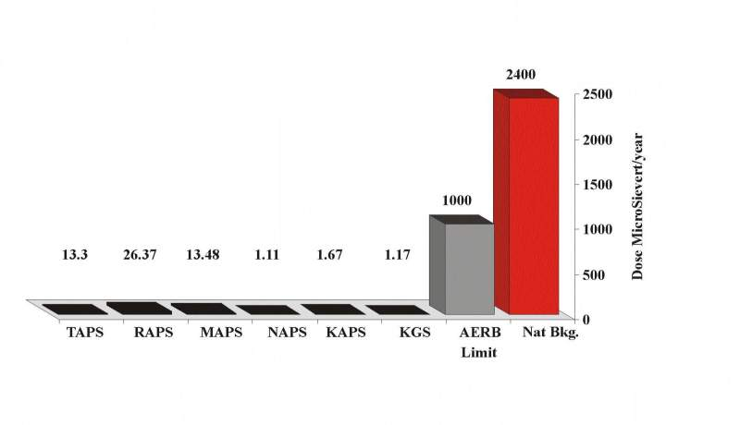Figure 11: The radiation dose to the public from nuclear reactors is much smaller than the regulatory limit.

Another concern is regarding the nuclear waste which could remain a hazard for a period much longer than our life time. There are countries in the world which do not recycle the spent fuel quite in contrast with the Indian Nuclear Program which is based on recycling of spent nuclear fuel which we in fact consider as a resource rather than a waste. In the United States, for example, reprocessing was primarily done to extract Plutonium, which can be used for nuclear weapons. This can also pose a threat to the security of the world because there is always a possibility of such things falling into wrong hands leading to risks of nuclear terrorism. The United States has plenty of Uranium and fossil energy and thus they do not have any serious domestic energy issue. The US had therefore banned reprocessing of spent fuel excepting for scientific research. Today, the United States runs the largest nuclear power program and operates more than 100,000 MWe of nuclear power capacity and consequently they have the largest stock of spent fuel in the world awaiting resolution of issue of disposal of spent nuclear fuel.

According to the World Nuclear Association, there is a very large spent fuel inventory (approximately 270,000 tons) in the world. This can be a sufficiently large resource for future energy needs, if recycled. Further, in my opinion, permanent disposal of spent fuel is an unacceptable safety and security risk in the long term since it actually leads to creation of a Plutonium mine. Disposal of spent nuclear fuel has remained an unresolved issue for decades and is unlikely to be resolved any time in future. We need to liquidate the spent fuel inventory through recycling. France today recycles the entire amount of spent fuel it produces. We in India too have developed the capability to do so. The waste management challenges can be effectively met through reprocessing and recycling. Development of partitioning and transmutation technologies that reduce the radio-toxicity of waste products to the level of a Uranium mine in a period of around 300 years, can, in principle, effectively eliminate the long term waste management challenge.

Then there is still a concern that remains about the risk of diversion of nuclear material and the threat that it poses in the public domain. To address that one needs new kinds of reactors. There is already a talk of designing 4th generation nuclear reactors which promise to provide cost effective clean and reliable energy with minimal risk of proliferation. I believe that the Advanced Heavy Water Reactor (AHWR) that we have designed meets these objectives of 4th generation reactor systems. It provides long operator forgiving time, there is little chance of any radiological impact in public domain and it is significantly immune from insider threat as well as threat of diversion of weapon useable nuclear materials. For example, in case of an accident, even if there is a complete loss of power and further if the primary as well as secondary shutdown systems do not work - a situation far more rare and severe than anything that we can credibly imagine-, a normal reactor will heat up. But in AHWR in spite of all this the fuel temperature remains steady. Similarly all materials involved in the fuel cycle of this reactor are not weapon useable and thus relatively immune from the risk of diversion (Fig. 12).

Today nuclear energy scene is dominated by Thermal Reactors. Fast Reactors clearly would be necessary to enable growth of nuclear energy beyond the potential of thermal reactors and Thorium would come in to extend energy supply beyond what is possible with Uranium. This process of enhancing global energy supply has to be done with a fair degree of responsibility and global security consciousness. India is successfully moving on this path. However, we also need parallel strategies for a broader geographical spread of nuclear power deployment. We thus also need to pursue reactors like AHWR to be able to deploy nuclear energy on a wider geographic domain without the fear of proliferation. And I think a proper combination of the two strategies will take the world forward towards the energy security. I believe, India has an opportunity and we should proactively move forward on this strategy for the benefit of our country as well as the world at large (Fig. 13).

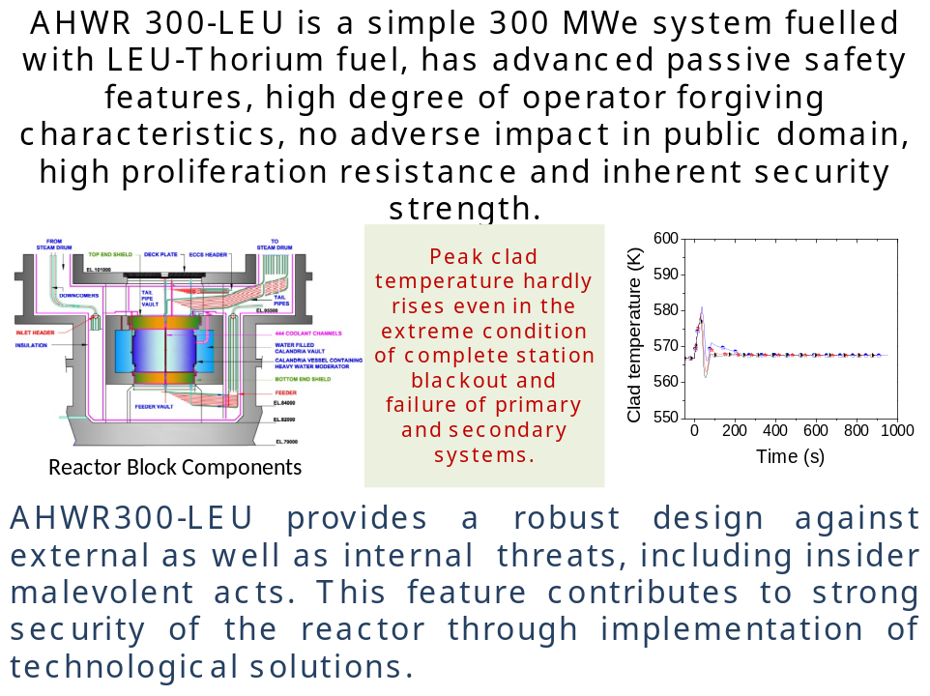

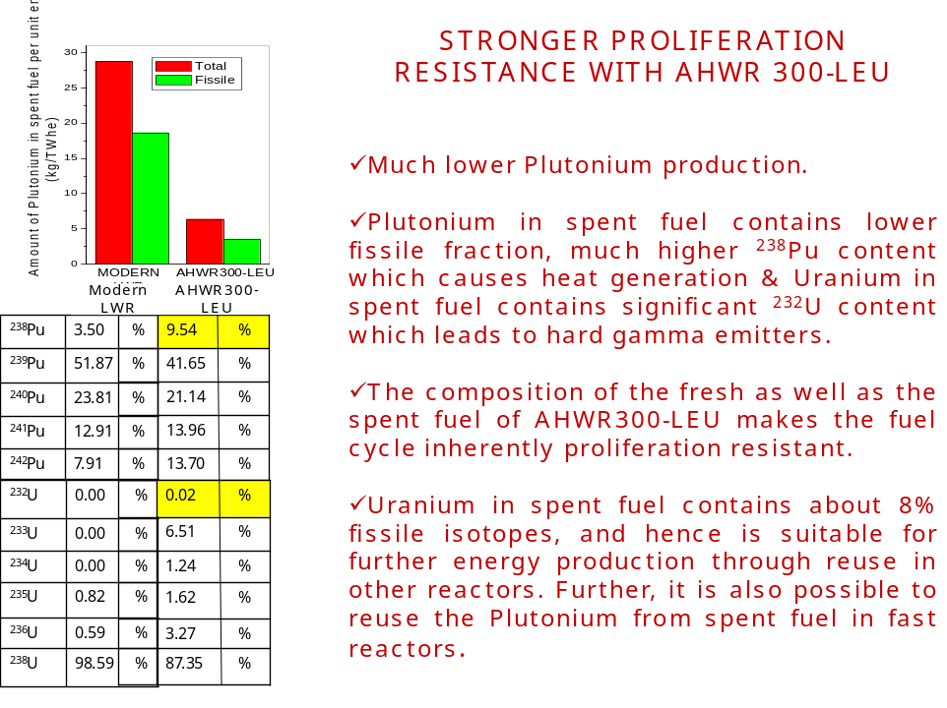

Fig. 12. 4th generation features in Advanced Heavy Water Reactor

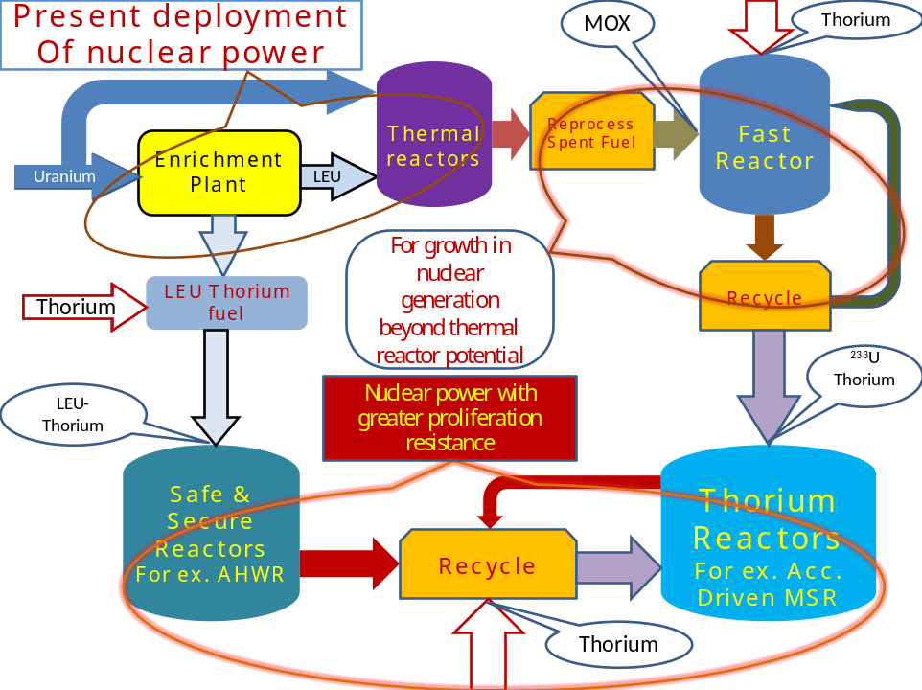

Fig.13. Strategy for deployment of nuclear power

Let me now make some observations on solar energy. As an inexhaustible and renewable source, solar energy will always remain an attractive proposition. However, as I mentioned in the introduction, it remains very capital intensive and is surviving today because of heavy Government subsidy. The challenge is to cut the capital cost down for both generation and storage. In this context, in my view it makes sense to deploy solar- biomass hybrids. If we run biomass with solar plant, you will find that you can extend the number of hours you can supply electricity from such a plant and considerably save on battery cost. Similarly I believe, significant efficiency gains can be derived through hybrids like solar- thermal and solar- photovoltaic based on concentrating solar light on a smaller PV surface area and developing high temperature capable PV materials.

Solar thermal is good for large capacity solar plants and we can install such plants in places having plenty of sunshine. However, areas which have good sunshine are also prone to scarcity of water, e.g. Rajasthan Desert. So we need to develop technology where power generation does not depend on availability of plenty of water, as is the case today. These are some challenges. Unfortunately, our technology is driven by what’s happening in west. We need to understand the ground reality of our country and develop our research strategies and technology consistent with the same.

We can get electrical power from both nuclear and solar sources. This however, does not address the problem of fluid fuel such as gasoline which is used to run cars, aircrafts etc. Since we may well be past the oil peak, an idea that has gained ground over the last decade or so is to replace the fossil fuel by hydrogen fuel. As pure hydrogen does not occur in nature on a large scale, one has to devise ways of producing it. In principle, if the temperature is sufficiently high, water molecules can be efficiently split into its constituents, i.e., oxygen and hydrogen. This can be done by using any of the primary energy sources, for instance using solar or nuclear route. However, the cost effective technology of both generation and storage of hydrogen energy is in a nascent stage. Further, we already have so much of investment and infrastructure based on petrol or diesel driven vehicles that even when the hydrogen technology becomes a reality, it will still require a huge auxiliary investment to convert/replace vehicles to the new technology. So we still require hydrocarbons which are depleting fast. We thus must find a way to artificially produce hydrocarbons which can be readily used as a fuel for transportation. One way is to use biomass, and methane is a good possibility. There are also people who are working on producing liquid fuel from biomass by incorporating externally produced hydrogen. What about producing hydrocarbons through chemical reactions involving carbon dioxide and hydrogen? This is theoretically possible and a lot of research is going on in this. If we do succeed in producing close substitutes for Diesel and Petrol by this process, it has the added advantage of recycling carbon dioxide and making a slow but sure transition to hydrogen fuel. There is a long and arduous way to go before this becomes a reality. Fig.14 depicts a schematic of such a programme.

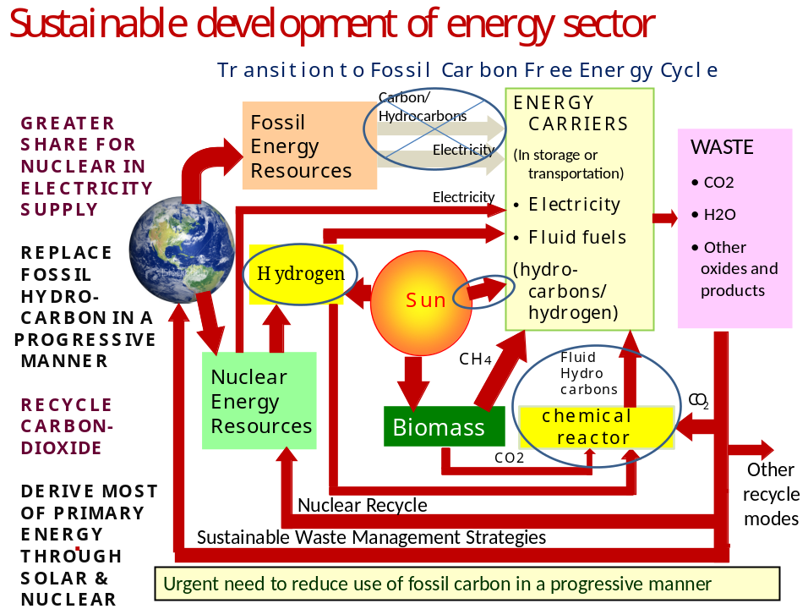
Figure 14 : An integrated approach to energy generation.

I will end this talk by pointing out a few perceptional problems and the reality in that context (Fig. 15). A common misperception that is sought to be conveyed is that a nuclear reactor can cause an explosion like a nuclear bomb. Principle of physics will tell you that this is impossible; a nuclear reactor can only heat up, it cannot explode. Associating pictures of large mushroom cloud that rises in a nuclear explosion with a reactor is a total misrepresentation. Another misconception is that radiation exposure around a nuclear plant would cause increased cancer burden. Often pictures of deformed children are shown stating that to be due to radiation from nuclear plants. The fact is that these reports have been found to be untrue. As we have seen, at low levels of radiation this is totally unlikely.
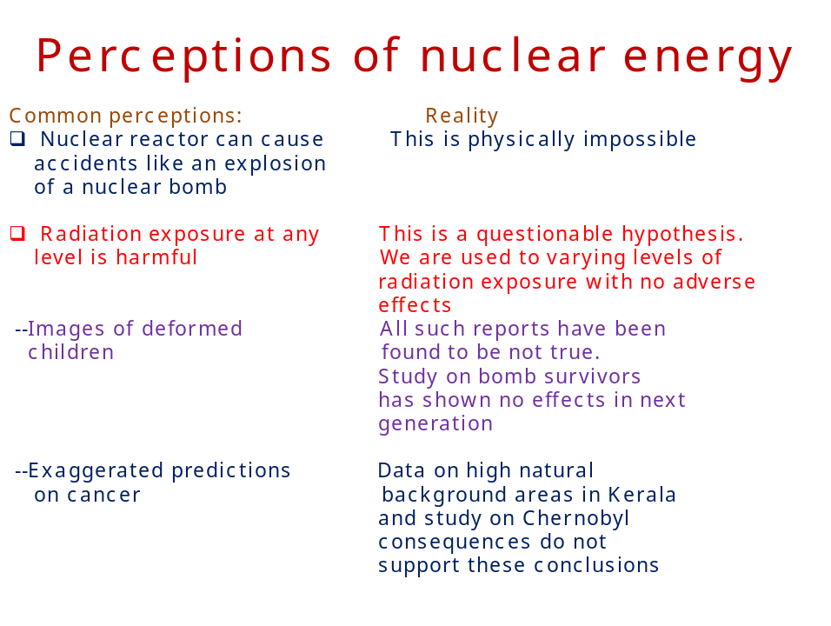
Figure 15 : Perceptions and facts regarding nuclear energy.

Nuclear energy provides 16% of the world’s electricity today and it has been supplied for decades in a cost effective manner. Despite Fukushima, or Chernobyl or Three Mile Island, the real risk of nuclear energy is the lowest amongst various other forms of energy in commercial use. The advantage of nuclear would be seen to be much greater if one factors in additional risks associated with the predicted consequences of climate change as a result of use of fossil energy in business as usual manner. That could well be a bigger killer then several atom bombs together.

I end this talk with a picture from the Kaiga Atomic Power Station with the message that “Nuclear is Green”! (see cover photo).

Acknowledgement :

I would like to thank Principal of Khalsa College Dr. Ageet Singh, my colleague Dr. R. R. Puri and Ms. Kalpana Sule, who has been instrumental in my coming here.

Based on DAE – C V Raman Lecture 2011-12 delivered by the author at the Guru Nanak Khalsa College of Arts, Science and Commerce on February 4, 2012

